**CHAPTER 1**

**PREAMBLE**

A preamble is an introductory statement in a document that explains the document's purpose and underlying philosophy. When applied to the opening paragraphs of a statute, it may recite historical facts pertinent to the subject of the statute. Preamble includes the introduction, literature survey, motivation to the project, problem statement, objective of the statement, limitations and enhancements of the study and organization of the document.

**1.1 Introduction**

Projects have become an integral part of the academic course, managing all the project manually is a laborious activity. Equipo Management is a comprehensive web-based solution for managing projects at a college scope.

The powerful features of Equipo Management system, has solved different project related problems by using some modules which increases the users satisfaction and retention through improved responsiveness.

Features of Equipo Management System

Administrator adds new users and maintains all the details of the users of Equipo Management such as

* + Configuration of the application
  + Authorisation ID
  + Name of the user
  + Password for user
* Up gradation of the user details can be done by the administrator.
* Login is possible for a user only using the passwords assigned by the administrator.
* The forum can be opened, controlled and closed only by the administrator.
* The administrator manages the load on the file server by performing file maintenance (documents and synopsis) on the server.
* The administrator can either modify or delete marks based on the user requirement.
* The users of the system are differentiated based on the Authorisation ID provided by the administrator.
* The user (Head Of the Department/Guide) can view the files (synopsis and documents) uploaded by various teams.
* The user (Head Of the Department/Guide) can communicate with the teams as well as make updates using the general forum.
* The user (Head Of the Department/Guide) can make evaluations based on the documents submitted by the teams.
* The user (teams) can upload their files (documents, synopsis) before the set deadlines.
* The user (teams) can use the forum to view updates and post queries.
* The user (teams) can view the evaluations made by Head Of the Department/Guide.

**1.2 Literature Survey**

The task towards complying with mandatory requirement of BE final year project work has been taken up by us with all spirit and zeal right from the inception. At the outset the efforts at IISC, Bangalore. Though the IISC was kind enough to provide all required support, for the distance and traffic inconvenience purpose, we were forced to look towards other alternatives. We also tried out for companies located proximate to our college and residence situated in Koramangala industrial area. Though a few contacted companies gave a positive response and were in their support for the project, but did not provide the same project for all the team members.

The discussion with our internal guide lead us to the thought of many innovative ideas such as the development of android application, online internal system, and paperless hospital, SIP Phone and few others. The discussion motivated us to come up with the idea of “Equipo Management”. The proposal of the new idea was approved by the Head Of the Department along with the required support.

**1.2.1 Existing System**

The project activities in the colleges used a patron system which was being followed from decades. The different project phases had many manual interactions involved, which was very time consuming along with physical presence throughout the process. In order to show the progress to the guide and Head Of the Department teams had to wait indefinitely without proper communication. The review dates and evaluated marks involved oral communications or having to put up print outs which would leave the absentees with no information regarding the project activities.

The previously existing system of project management and their suggestions and evaluations was a long procedure. Existing system was nominal and various flaws were visible, it was time consuming in a scenario like todays, no man likes waiting, so a system which manages all their activities online for the department was devised.

**1.2.2 Evolution**

The new system was able to overcome the imperfections of the previously existing system. The new system “Equipo Management” was inspired from the current day trends, the related modules were taken up from the various project phases in different colleges and universities. In order to look into the system, an approach was made to the various people working for the respective academicians. Thereafter the project management systems were analysed and the correlated modules were used in our “Equipo Management System”.

The new inspired system was made to overcome the shortcomings of the existing system and it replicated the various new features from all the above mentioned management systems. Using the above system it is now possible to manage all project related activities online.

**1.3 Motivation**

The prevailing system of managing projects at colleges is of primitive style such as manual submissions, approval of project ideas and other project related procedures. However the major communications of the problems were carried out orally which had no proper records. The present days of electronic media needed renovation of the system and required induction of latest methodology. In the process it was thought that managing of projects through a system specially designed for the purpose would do the needful.

In connection, the motivation by Head Of the Department and Guide helped to develop a new method wherein the students at colleges can easily submit their project documents in quick time interval to get it evaluated by the respective authorities.

**1.4 Statement of Problem**

A problem statement is a concise description of the issues that need to be addressed by a problem solving team and should be presented to them (or created by them) before they try to solve the problem. The section contains the problem definition and problem explanation.

**1.4.1 Problem Definition**

Piles of papers and wasted time seize the speed of project management and make it ineffective. The latest productivity enhancement system which is able to manage projects online is Equipo Management system. The different phases of the project are carried out online in a more efficient way. The paperless communication of the project management enhances the speed of handling it efficiently compared to the manual mode. The management system also provides report and status of the projects.

The project entitled “EQUIPO MANAGEMENT SYSTEM” (EMS) is an application in python which is implemented on a web development frameworkDjango1.3 platform with support of ORM (object relational mapping) technology in which it is possible to perform database operations without having to write tedious and ambiguous queries. The classes are converted to tables and functions become queries when using the ORM API.

**1.4.2 Problem Explanation**

* **Logging in**: Using Login administrator, Head Of the Department, Guide and Teams are able to access the Equipo Management System, if the username, auth-id and password is correct.
* **File Management**: Using File Management, user can upload/view files (documents, synopsis).
* **Forum**: Forum is used for communication, update and for posting queries/replies**.**
* **Evaluation**: Evaluation is used for making evaluations/allotting marks and for viewing the allotted marks.
* **Admin:** The admin can use the Administration Site for registering users, opening/closing forums, managing uploaded files, taking back up of uploaded documents and correcting wrong entries.

**1.5 Objective of the Study**

The objective of Equipo Management System was to eliminate the manual involvement of many faculties and students at college/university to manage the projects. There were lots of preliminary works that had to be done prior to starting the project such as submitting the hard copies of synopsis initially for the approval and submitting of hard copies of documents at the later stages of the project which would consume more time and involve a lot of paper work.

Equipo Management System brings out a change in the way by which projects are handled. In Equipo Management System, instead of handling the projects by the manual means, projects are managed efficiently online through the Equipo Management System.

Using Equipo Management System reduces the amount of time consumed in arranging and conducting meetings for announcing the updates. In Equipo Management System since back up of all the documents can be done by the administrator there are losses of data or documents.

**1.6 Limitations and Enhancements of the Study**

The section provides limitations and enhancements of the EMS application.

**1.6.1 Limitations**

Every software has its own advantages as well as certain limitations. Few of the limitations that can be found in Equipo Management System may be

* Awareness about the application and its proper usage. Certain users may not be aware about this system and its facilities.
* There may be certain situation where the students may not be well experienced enough to handle the application.
* There may be certain situations where the server maybe overloaded in the absence of the administrator, the application may crash.
* Problems may be incurred in the LAN connection. The deployment of the software must be done properly.

**1.6.2 Enhancements**

A fully fledged mobile application could be developed which eliminates the usage of computers and various project activities can be completed on the move via 3G or Wi-Fi connections.

**1.7 Organization of the Report**

The rest of the document is organized as follows

* **Chapter 2** includes the system requirement specification, which specifies the functional and non-functional requirements of the system.
* **Chapter 3** includes the design of the project where the system architecture strategies, preliminary design, a detailed description of different features along with the use case diagrams, data flow diagrams are specified.
* **Chapter 4** includes the implementation details.
* **Chapter 5** includes the testing, which specifies how the different modules of the project are tested for its correct working.
* **Chapter 6** includes the conclusion and future enhancements.
* **Appendix A** includes the snapshots of the system.

**CHAPTER 2**

**SYSTEM REQUIREMENTS AND SPECIFICATIONS**

The chapter describes system requirements and specification which establishes the requirements for Equipo Management System. System requirements specify the users along with requirements like functional and data.

**2.1 Purpose of the Document**

The purpose of the document is to provide a bounded physical representation of body of information design with the capacity and usually intent to communicate. Document manifests symbolic diagrammatic or sensory representational information about our project. Thus, it produces a document artifact by collecting and representing information and also helps the user to understand about the project in an easy manner. The documentation gives an overview of functional requirements and data requirements. The document explains hardware and software requirements, user view of product use, general constraints and guidelines of a project.

Document gives the information about the project and how to use it. And also provide the information on how to run this project and what is the compatibility issue and information of the general feature provided by the project.

**2.2 General Description**

Under the topic, the description of the users who uses the system along with their characteristics is specified. And also describes briefly the functional and data requirements of the project like Users and their Characteristics, Product Perspective, Overview of the Functional Requirements, Non Functional Requirements and Data Requirements, General Constraints and assumption Dependencies, User View of product use and Hardware and Software Requirements. This topic on the whole gives a detailed information about various aspects of the system being developed and data flowing through the system and the management of the data at various levels in the system.

* + 1. **Users and their Characteristics**

Users of the system are the Head Of the Department’s, Guide’s and the Team members with the following characteristics:

* Head Of the Department views files (synopsis, documents), posts updates, makes evaluations.
* Administrator creates users, authorizes users, manages load on server by performing maintenance.
* Guide’s view files (synopsis, documents), makes evaluations.
* Team members upload files (synopsis, documents), views evaluated marks.

**2.2.2 Product Perspective**

The application allows the student of the college to submit all project related requirements online, to be viewed by the respective authorities. The updates made by the Head Of the Department can be viewed by the teams and all communications can be done by using the general forum. The submitted files are viewed by the Head Of the Department and Guide’s and evaluations are made accordingly which can be viewed by the team members. The administrator can modify, delete contents on the server to maintain the load on the server.

**2.2.3 Overview of Functional Requirements**

Functional requirements define the internal workings of the software that is the calculations, technical details, data manipulation and processing, and other specific functionality. These are supported by non-functional requirements, which impose constraints on the design of implementation (such as performance requirements, security, quality standards, or design constraints).

The core of this requirement is the description of the required behavior, which must be a clear and readable description of the required behavior. A typical functional requirement will contain a unique name and number, a brief summary and a rationale.

**2.2.4 Overview of Non-Functional Requirements**

In systems engineering and requirements engineering, a non-functional requirement [5] is a requirement that specifies criteria that can be used to judge the operation of a system, rather than specific behaviors. The above should be contrasted with functional requirements that define specific behavior or functions.

In general, functional requirements define what a system is supposed to do whereas non-functional requirements define how a system is supposed to be. Non-functional requirements are often called qualities of a system. Qualities, that is, non-functional requirements, can be divided into two main categories:

* Execution qualities like security and usability which are observable at run time.
* Evolution qualities, such as testability, maintainability, extensibility and scalability, which are embodied in the static structure of the software system.

Typical non-functional requirements are reliability, scalability, and cost. Non-functional requirements are often called ileitis of a system. Other terms for non-functional requirements are "constraints", "quality attributes", "quality goals" and "quality of service requirements”. Non-Functional requirements are some requirements which are not directly concerned with the specific functions delivered by the system and may relate to emergent system properties such as reliability, scalability and response time.

**2.2.5 Overview of Data Requirements**

The Head Of the Department, Guide’s and team members have to enter Username, Password and Authorization ID that will open the respective dashboard for user access.

User names, passwords and authorization ID is provided by the administrator at the time of registration for using EMS. For the forum to be used the administrator should open and posts, threads in the forum can only be deleted by the administrator.

The system must have sufficient disk capacity to store all the files, documents and synopsis uploaded to the server, that admin must therefore perform periodical maintenance.

**2.2.6 General Constraints and Assumptions Dependencies**

The general constraints and assumptions made are presented as follows:

**General Constraints**

* The database and server should be available every time for user access.
* For transaction and profile view, valid credentials are required.

**Assumptions Dependencies**

* For connection, user needs to specify User ID, Auth ID and Password.
* For admin connection, admin has to provide the Admin ID and Password which is used during installation.

**2.2.7 User View of Product Use**

To view the dashboard and use the features, the user has to provide the User ID and Password for authentication. To view the admin interface, the admin has to provide the ID and Password for connection.

The options provided for administrator are

* Adding users to the site
* Opening/closing forums
* Changing passwords(if required)
* Manages files uploaded on to the server
* Correcting wrong mark entries
* Provides authorization ID’s
* Making a backup copy of the files uploaded on the server
* Deleting irrelevant posts or threads on the forum

The options provided for Head Of the Department are

* Viewing uploaded synopsis and documents.
* Making evaluations.
* Posting updates on update forum.
* Answering queries on general forum.

The options provided for the Guide are

* Viewing uploaded synopsis and documents.
* Making evaluations.
* Answering queries on general forums.

The options provided to the teams are

* Uploads synopsis for approval.
* Uploads project related documents.
* Can use reference section for preparing reports.
* Post/answers queries on general forum.
* Views updates on update forum.
* Views guide/Head Of the Department evaluated marks.

When the user signs out, the home page will appear.

**2.2.8 Hardware and Software Requirements**

The hardware requirements and software requirements are as follows:

**Hardware Requirements**

The most common set of requirements defined by any operating system or software application is the physical computer resources. The minimum or ample amount of hardware resources required for installing and smooth functioning EMS on the system is mentioned here.

Following are the various aspects of hardware requirements

* Main processor : Pentium4 or Later Versions
* RAM size : 1 GB
* Hard Disk : 80 GB

**Software Requirements**

Software requirements deal with defining software resource requirements and pre-requisites that need to be installed on a computer to provide optimal functioning of an application. The above requirements or pre-requisites are generally not included in the software installation package and need to be installed separately before the software is installed.

Following are the various aspects of software requirements

* Operating System : Linux
* Platform Used : Django-1.3
* Software Environment : Python 2.7
* Server Used : Django development Server
* Browser Used : Google Chrome/Mozilla

**CHAPTER 3**

**SYSTEM DESIGN DESCRIPTION**

The chapter specifies the design description of “The Equipo Management System”. The phase gives a clear idea of system to be implemented understandability can be increased with diagrams or pictorial representation than the textual matter written describing the project. The design description consists of preliminary design and detailed design. Preliminary design specifies the low level design.

**3.1 Preliminary design**

The purpose of the designed is to plan the solution of a problem specified by the system requirements. Design phase is the first step in moving from problem to solution domain. In other words, starting with what is needed design takes us to work how to satisfy the needs. The design of the system is perhaps the most critical factor affecting the quality of the software and has a major impact on the later phases, particularly testing and maintenance.

The preliminary design phase may also be known as conceptual design or architectural design. During this phase, the high-level design concept is created which will help to implement the complex system requirements. The design concept may be expressed as functional block diagrams, design and architecture descriptions, sketches, and/or behavioral HDL (Hardware Description Language).

The preliminary design bridges the gap between the design concept and the detailed design phase. In the task, the overall system configuration is defined, the schematics diagrams, and layouts of the project will provide early project configuration. During detailed design and optimization, the parameters of the part being created will change, but the preliminary design focuses on creating the general framework to build the project on. For the preliminary phase, the main goal is to map out how the complex electronics will perform the functions specified in the requirements, within the constraints of the device, the defined interfaces, and the environment the device or application will operate within.

**3.1.1 Layout of Equipo Management**

Figure 3.1 shows the layout of Equipo Management, which is used to describe the functionality of the project management application. The main objective of Equipo Management is to provide an application to the users with a friendly and interactive interface which will help the users in solving their manual project management hindrances. Equipo Management supports the three types of users namely Teams, Guide and Head Of the Department who are associated with different universities and colleges.

**Figure 3.1 Layout of Equipo Management**

**3.1.2 Technologies Used**

**Introduction to Python Programming Language**

**Python [1] is a programming language that lets work more quickly and integrates the systems more effectively. In learning python, one can see almost immediate gains in productivity and lower maintenance costs.** Python runs on Windows, Linux/Unix, Mac OS X, and has been ported to the Java and .NET virtual machines. Python is free to use, even for commercial products, because of its OSI-approved open source license. Python has efficient high-level data structures and a simple but effective approach to object-oriented programming. Python’s elegant syntax and dynamic typing, together with its interpreted nature, make it an ideal language for scripting and rapid application development in many areas on most platforms.

The history of the Python programming language dates back to the late 1980s.Python was conceived in the late 1980s and its implementation was started in December 1989 by Guido van Rossum at CWI in the Netherlands as a successor to the ABC programming language capable of exception handling and interfacing with the Amoeba operating system. Van Rossum is Python's principal author, and continuing central role in deciding the direction of Python is reflected in the title given to Rossum by the Python community, Benevolent Dictator for Life (BDFL).

Python 2.0 [1] was released on 16 October 2000, with many major new features including a full garbage collector and support for Unicode. However, the most important change was to the development process itself, with a shift to a more transparent and community-backed process. Python 3.0, a major, backwards-incompatible release, was released on 3 December 2008 after a long period of testing. Many of its major features have also been [back ported](http://en.wikipedia.org/wiki/Backport) to the backwards-compatible Python 2.6 and 2.7.

**Overview**

Python is a general-purpose, high-level programming language whose design philosophy emphasizes code readability. Python's syntax allows programmers to express concepts in fewer lines of code than would be possible in languages such as C, and the language provides constructs intended to enable clear programs on both a small and large scale.

Python supports multiple programming paradigms, oriented including object [1], imperative and functional programming styles. Python also features a dynamic type system and automatic memory management and has a large and comprehensive standard library.

Similar to other dynamic languages, Python is often used as a scripting language, but is also used in a wide range of non-scripting contexts. Using third-party tools, Python code can be packaged into standalone executable programs. Python interpreters are available for many operating systems.

Python uses dynamic typing and a combination of reference counting and a cycle-detecting garbage collector for memory management. An important feature of Python is dynamic name resolution (late binding), which binds method and variable names.

The design of Python offers only limited support for functional programming in the Lisp tradition. The python interpretred language has map(), reduce() and filter() functions, comprehensions for lists, dictionaries, and sets, as well as generator expressions. The standard library has two modules namely itertools and functools.

**The Python Interpreter**

The Python interpreter [7] and the extensive standard library are freely available in source or binary form for all major platforms and may be freely distributed. The same also contains distributions of and pointers to many free third party Python modules, programs and tools, and additional documentation. The Python interpreter is easily extended with new functions and data types implemented in C or C++ (or other languages callable from C). Python is also suitable as an extension language for customizable applications.

The Python interpreter is usually installed as /usr/local/bin/python on those machines where it is available; putting /usr/local/bin in UNIX shell’s search path makes it possible to start it by typing the command: “python” to the shell.

**Introduction to Django**

Django is an excellent framework [2] for rapid development of web applications and looks at automating regular tasks involved while developing web app’s such as login, logout actions, form verification. Django also provides an excellent template language where in it is possible to html and python processing seamlessly.  Also Django provides full support for ORM based programming by providing a common API for popular databases such as mysql, postgrey and sqlite etc.

In the python powered Django Framework [2] views.py is the place to write the view logic of the website and simply this is to specify how the webpage looks, models.py is the place to create the backend databases, which avoids writing cumbersome queries. Creating classes and defining functions to operate on the class, Django converts the classes into tables and members of the classes into attributes and that is the beauty of ORM supported by Django.

Last thing to know is the urls.py file in <project-name> folder , to specify the urls using regular expressions and specify the corresponding view functions to be called when django encounters the particular url.

**Introduction to Django Templating language**

Django’s template language is designed to strike a balance between power and ease. The template is designed to feel comfortable to programmers used to work with HTML [2]. The Django template system provides tags which function similarly to some programming constructs – an ‘[if](https://docs.djangoproject.com/en/dev/ref/templates/builtins/#std:templatetag-if)’ tag for Boolean tests, a ‘[for](https://docs.djangoproject.com/en/dev/ref/templates/builtins/#std:templatetag-for)’ tag for looping, etc. But these are not simply executed as the corresponding Python code, and the template system will not execute arbitrary Python expressions. Only some of the tags, filters and syntax are supported by default. One can add own to the template language as needed.

* **Templates**

A template is simply a text file. Template can generate any text-based format (HTML, XML, CSV, etc.).A template contains variables, which get replaced with values when the template is evaluated, and tags, which control the logic of the template.

## Variables

Variables are represented like this: {{ variable }}. When the template engine encounters a variable, it evaluates that variable and replaces it with the result. Variable names consist of any combination of alphanumeric characters and the underscore ("_"). The dot (".") also appears in variable sections, although that has a special meaning, as indicated. Importantly, there cannot be any spaces or punctuation characters in variable names.

* **Filters**

The variables for display can be modified by using **filters**. Filters are represented like: {{ name|lower }}. Filter displays the value of the {{name }} variable after being filtered through the [lower](https://docs.djangoproject.com/en/dev/ref/templates/builtins/#std:templatefilter-lower) filter, which converts text to lowercase.

Use a pipe (|) to apply a filter.Filters can be “chained.” The output of one filter is applied to the next. {{ text|escape|linebreaks }} is a common idiom for escaping text contents, then converting line breaks to <p> tags.Some filters take arguments. A filter argument looks like this: {{bio|truncatewords:30}}. The argument will display the first 30 words of the bio variable. Filter arguments that contain spaces must be quoted; for example, to join a list with commas and spaced use {{ list|join:", " }}.Django provides about thirty built-in template filters.

The impact functions available in Django are:

* Authentication
* Login
* Logout
* Reverse
* Pagination
* Login_Required

**Authentication function**

To authenticate a given username and password, we use authenticate(). The function takes two keyword arguments, username and password, and it returns a User objects if the password is valid for the given username. If the password is invalid, authenticate() returns None.

**Login Function**

For a user to Login in a view, use the [login()](https://docs.djangoproject.com/en/1.2/topics/auth/#django.contrib.auth.login) function. The function takes an [HttpRequest](https://docs.djangoproject.com/en/1.2/ref/request-response/" \l "django.http.HttpRequest" \o "django.http.HttpRequest) object and [User](https://docs.djangoproject.com/en/1.2/topics/auth/#django.contrib.auth.models.User) object. [login()](https://docs.djangoproject.com/en/1.2/topics/auth/#django.contrib.auth.login) saves the user’s ID in the session, using Django’s session framework. The login function also saves the user credentials and session data until the user logs out of the system.

**Logout Function**

To Logout a registered user who has been logged in via [django.contrib.auth.login()](https://docs.djangoproject.com/en/1.2/topics/auth/" \l "django.contrib.auth.login" \o "django.contrib.auth.login), use [django.contrib.auth.logout()](https://docs.djangoproject.com/en/1.2/topics/auth/" \l "django.contrib.auth.logout" \o "django.contrib.auth.logout) within the view. The function takes an [HttpRequest](https://docs.djangoproject.com/en/1.2/ref/request-response/" \l "django.http.HttpRequest" \o "django.http.HttpRequest) object and has no return value.

**Reverse Function**

A common need when working on a Django project is the possibility to obtain URLs in the final forms either for embedding in generated content (views and assets URLs, URLs shown to the user) or for handling of the navigation flow on the server side (redirections).

Django provides a solution such that the URL mapper is the only repository of the URL design. One can feed it with URLconf and then it can be used in both directions:

* Starting with a URL requested by the user/browser, it calls the right Django view providing any arguments it might need with their values as extracted from the URL.
* Starting with the identification of the corresponding Django view plus the values of arguments that would be passed to it, obtain the associated URL.

**Pagination**

Django provides a few classes that help you manage paginated data – that is, data that’s split across several pages, with “Previous/Next” links.

These classes live in django/core/ paginator.py.

**Login_required function**

login_required()does the following:

* If the user is not logged in, redirect to settings. LOGIN_URL, passing the current absolute path in the query string.
* If the user is logged in, execute the view normally. The view code is free to assume the user is logged in.

**Django development Server**

Django development server is a light weight server and debugger capable of executing django programs. By default, the server runs on port 8000 on the IP address 127.0.0.1. IP address and port number can be passed explicitly. The server is configured to dynamically compile python scripts and execute [2].

**SQLite Database**

SQLite is an embedded relational database engine. Developers call it a self-contained, server less, zero-configuration and transactional SQL database engine. SQLite is very popular and there are hundreds of millions copies worldwide in use today. SQLite is used in Solaris 10 and Mac OS operating systems, iPhone or Skype. Qt4 library has a built-in support for the SQLite as well as the Python or the PHP language. Many popular applications use SQLite internally such as Firefox, Google Chrome or Amarok.

SQLite implements most of the SQL-92 [4] standard for SQL. The SQLite engine is not a standalone process. Instead, it is statically or dynamically linked into the application. SQLite library has a small size and could take less than 300 KiB. A SQLite database is a single ordinary disk file that can be located anywhere in the directory hierarchy. SQLite is a cross platform file which can be used on various operating systems, both 32 and 64 bit architectures. SQLite is created in C programming language and has bindings for many languages like C++, Java, C#, Python, Perl, Ruby, Visual Basic, Tcl and others. The source code of SQLite is in public domain.

**Starting the Installation**

1. Open a terminal, type: sudo apt-get install python-django.
2. Verify the installation by typing django-admin.
3. Create a directory and change into that created directory.
4. Start the project by typing django-admin startproject<project-name>.
5. Start the app by typing python manage.py startapp<app-name>.

**Configuring SQLite3**

1. Open the settings.py file and enter name and path to the database to be created and used.
2. In the terminal type the command python manage.py syncdb and enter the details.

**Completing the Configuration**

1. In the terminal type the command python manage.py runserver.
2. If there are no errors in the program, in the browser enter the url localhost:8000.

If the installation has been completed successfully the django welcome will be displayed on the browser.

**JavaScript**

JavaScript (JS) is an interpreted computer programming language which was originally implemented as part of web browsers so that client-side scripts could interact with the user, control the browser, communicate asynchronously and alter the document content that was displayed [3].

JavaScript is a prototype-based scripting language that is dynamic, weakly typed, and has first-class functions. The syntax was influenced by the language C. JavaScript copies many names and naming conventions from Java, but the two languages are otherwise unrelated and have very different semantics. The key design principles within JavaScript are taken from the self and Scheme programming languages. Javascript is a multi-paradigm language, supporting object-oriented, imperative, and functional programming styles.

**HTML**

Hyper Text Markup Language (HTML) is the main mark-up language for creating unique web pages and other information that can be displayed in a web browser [3].

HTML is written in the form of HTML elements consisting of *tags* enclosed in angle brackets (like <html>), within the web page content. HTML tags most commonly come in pairs like <h1> and </h1>.

The first tag in a pair is the *start tag*, the second tag is the *end tag* (they are also called *opening tags* and *closing tags*). In between these tags web designers can add text, tags, comments and other types of text-based content.The purpose of a web browser is to read HTML documents and compose them into visible or audible web pages. The browser does not display the HTML tags, but uses the tags to interpret the content of the page.

HTML elements form the building blocks of all websites. HTML allows images and objects to be embedded and can be used to create interactive forms. Also, this provides a means to create structured documents by denoting structural semantics for text such as headings, paragraphs, lists, links, quotes and other items. HTML can embed scripts written in languages such as JavaScript which affect the behaviour of HTML web pages. Web browsers can also refer to Cascading Style Sheets (CSS) to define the appearance and layout of text and other material.

**ORM (Object Relational Mapping)**

Object relational mapping in computer software is a programming technique for converting data between incompatible type systems in object oriented programming languages. ORM creates, in effect, a “virtual object database” that can be used from within the programming language. The heart of the problem is translating the logical representation of the objects into an atomised form that is capable of being stored on the database, while somehow preserving the properties of the objects and their relationships so that they can be reloaded as an object when needed. If the storage and retrieval functionality is implemented, the object are then said to be persistent.

**3.1.3 Design Considerations**

System designing is a solution, “how to approach to the creation of a new system”. System designing is important phase provides the understanding and procedural details necessary for implementing the system recommend in the feasible study. The design step produces a data design, an architectural design and a procedural design.

The data design transform the information domain model created during analysis into data structures that will be required to implement the software. The architectural design defines the relationship among the major structural components into a procedural description.

Source code is generated and testing is conducted to integrate and validate the software. From a project management of view, software design is conducted in two steps, given as follows

* The preliminary design is concern with the transformation in to data and software architecture.
* Detailed design focuses on refinement to the architectural representation that lead to detailed data structure and algorithmic representations for software.

**Data Design**

Data design is the first of the three design activities that are conducted during software engineering. The impact of the data structure and procedural complexity causes data design to have a profound influence on the software quality. The concept of information hiding and data abstraction provides the foundation for an approach to data design.

**Architectural Design**

The primary objective of the architectural design is to develop a modular program structure and represent the control relationship between modules. In addition, architectural design models program structure and data defining interfaces that enable data to flow throughout the program.

**Procedural Design**

The primary design occurs after data and program structure has been established. Procedural detail can be specified by either of the following

* Structured programming
* Flowchart constructs
* Decision tables
* Structured English

**3.2 Architectural Strategies**

Architecture is defined as the formal, considered plan or design that guides development or construction of business systems. The application architecture strategy is the plan for developing the application architecture-the meta strategy. This is the focus of this document, within the preceding context.

The primary objective of the architectural design is to develop a modular program structure and represent the control relationship between modules.

In addition, architectural design models program structure and data defining interfaces that enable data to flow throughout the program.

The Modules of Equipo Management

**Administrator**

An administrator only has the authority to add the details of a new user or team. Admin is the person who has the authoritative powers to control the overall up gradations and deletions of the submitted documents by any one of the registered user of the application. Admin can remove a document from the application once it is of no further importance. The admin has to add the details of the new registered user and also can update the details of a user in the Admin Interface.

**Head Of the Department**

The Head Of the Department is the registered user of the application who has the benefits of using the features of the application such as view the uploaded synopsis, manage the file system, discuss and make updates in the forum, make the evaluation on team or individual basis.

The above mentioned features built in the module of Head Of the Department dash-board makes the prominent user of the application with the overall information of the time to time activities that take place in the project management application.

**Guide**

The Guide is the registered user of the application who has the benefits of using the features of the application such as view the uploaded synopsis, manage the file system, discuss and make announcements in the forum, make the evaluation on team or individual basis.

The Guide being a registered user of the project management application has the authority to view all the documents of the team and to suggest any improvisations on any module in the discussion forum.

**Team**

The members of the team will be registered to the application through the administrator. The registration makes the members of the team as the active users of the application to carry out their project phases online.

The Team dash-board has the modules such as the Synopsis-Creation, File-Management, View the Evaluated-Marks by the guide and Head Of the Department, and have conversations regarding any project activity in the Discussion Forum.

**3.3 Detailed System Design**

The detailed system design contains high level design, low level design, data flow diagrams, use case diagrams.

**3.3.1 High-level Design and Low-level Design**

**High-level Design**

The purpose of this phase will be to design the overall functioning of the proposed system and finalize the input and output format. The document of functions specifications should be presented in a language that can be understood by the administrator and the project teams. The Head Of the Department must approve the design, and the project team should then be able to move on to the subsequent phases.

**Low-level Design**

The purpose of this phase is to produce a detailed design of the software modules/units, based on the high-level design. The specifications for the various software modules of the system will be written at this time.

**3.3.2 The Software Architecture**

The Rational Unified Process [5] brings together elements from all of the generic process models, supports iteration and illustrates good practice in specification and design. The RUP is normally described from three perspectives as shown in Figure 3.2:

* A dynamic perspective that shows the phases of the model over time.
* A static perspective that shows the process activities that are enacted.
* A practice perspective that suggests good practices to be used during the process.



**Figure 3.2: Phases of RUP**

**Dynamic perspective**

The different phases in RUP are:

* **Inception**

The goal of the inception phase is to establish a business case for the system. Identifying all external entities that will interact with the system and defining these interactions. The information is used to assess the contribution of system to business.

* **Elaboration**

The goals of the elaboration phase are to develop an understanding of the problem domain, establish an architectural framework, develop project plan and identify key project risks.

On completion of this phase you should have requirements model for the system, architectural description and a development plan for the software.

* **Construction**

The phase is concerned with system design, programming and testing. Parts of the system are developed in parallel and integrated during this phase. On completion of this phase, team should have a working software system and associated documentation that is ready for delivery to users.

* **Transition**

Transition is the final phase of RUP and is concerned with moving the system from the development community to the user community and making it work in real environment. On completion of this phase, team should have a documented software system that is working correctly in its operational environment.

**Static perspective**

The static view of RUP focuses on the activities that take place during development process these are called workflows in RUP description. There are six core process work flows identified in the process and three core supporting workflows. The RUP has been designed in conjunction with the UML- an object oriented modeling language- so the workflow description is oriented around associated UML models. The core engineering and support workflows are as given in the table.

**Table 3.1: Static perspective of RUP**

|  |  |
| --- | --- |
| **Workflow** | **Description** |
| Business modelling | The business processes are modelled using business use cases. |
| Requirements | Actors who interact with the system are identified and use cases are developed to model the system requirements. |
| Analysis and Design | A design model is created and documented using architectural models, component models, object models and sequence models. |
| Implementation | The components in the system are implemented and structured into implementation sub systems. Automatic code generation from design models helps accelerate this process. |
| Testing | Testing is an iterative process that is carried out in conjunction with implementation. System testing follows the completion of the implementation. |
| Deployment | A product release is created distributed to users and installed in their work place. |
| Configuration and Change management | This supporting work flow manages changes to the system. |
| Project management | This supporting work flow manages the system development. |
| Environment | This work flow is concerned making Appropriate software tools available to the software development team. |

Practice perspective on the RUP describes good software engineering practices that are recommended for using systems development .Six fundamental best practices are recommended:

* Develop software iteratively. Plan increments of the system based on customer priorities and develop and deliver the highest priority system features early in the development process.
* Manage requirements. Explicitly document the customer’s requirements and keep track of changes to these requirements. Analyze the impact of changes on the system before accepting them.
* Use component-based architectures. Structure the system architecture into components.
* Visually model software. Use graphical UML models to present static and dynamic views of the software.
* Verify software quality. Ensure that the software meets the organizational quality standards.
* Control changes to software. Manage changes to the software using a change management system and configuration management procedures and tools.

**Business modeling**

Use case summaries

* File management: The service allows team members to create files, access the files, and also can perform modifications (append and delete).The guide and Head Of the Department can also view the contents any point of time.
* Updates: The feature allows the Head Of the Department to create and post updates which can be viewed by the teams.
* Forum: The feature allows all the actors to post and comment. Also updates can be created.
* FAQ’s and reference: The queries arising on a regular basis are answered here. Reference to standard project is also made available to teams.
* Evaluation: The feature allows the Head Of the Department and the Guide to view the progress of the various teams and perform evaluation.

**3.3.3 Data Flow Diagrams**

Data-flow models are an intuitive way showing how data is processed by a system. At the analysis level, they should be used to model the way in which data is processed in the existing system. The notation used in these models represents functional processing, data stores and data movements between functions.

Data-flow models are used to show how data flows through a sequence of processing steps. The data is transformed at each step before moving on to the next stage. The processing steps or transformation are program functions where dataflow diagrams are used to document a software design.

Users are able to visualize how the system will operate, what the system will accomplish and how the system will be implemented. Old system dataflow diagrams can be drawn up and compared with the new systems dataflow diagrams to draw comparisons to implement a more efficient system. Data-flow diagrams can be used to provide the end user with a physical idea of where the data they input, ultimately has an effect upon the structure of the whole system from order to dispatch to restock how any system is developed can be determined through a Data-flow diagram.

There are several common modeling rules to be followed while creating DFD’s are as follows:

* All processes must have at least one data flow in and one data flow out.
* All processes should modify the incoming data, producing new forms of outgoing data.
* Each data store must be involved with at least one data flow.

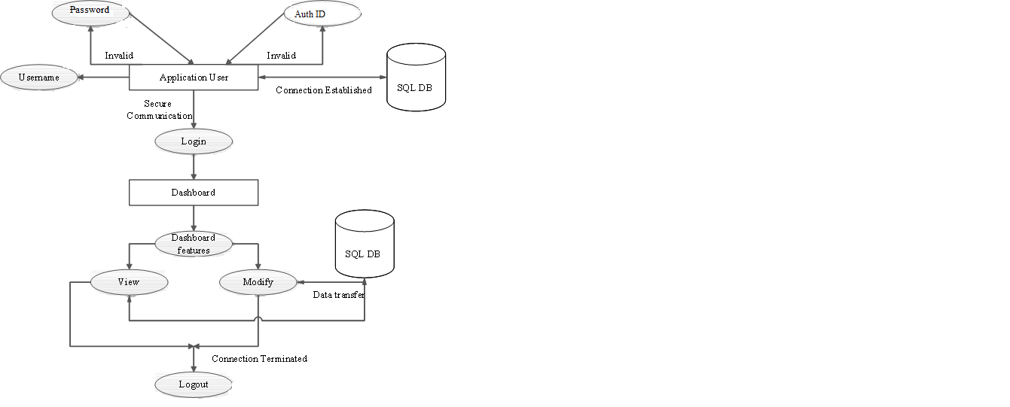

**Figure 3.3 Data Flow Diagram for Equipo Management**

The Figure 3.3 displays the functioning of the user module where, the user of the application can login can login by providing the required credentials and then a list of options are displayed to the respective user dash-board among which user can operate on. Admin would have the control over the entire system. Head Of the Department/Guide/Team would have the access to respective dash-board features. The user must Logout to return to the Home page.

**3.3.4Use Case View**

Figure 3.4 represents use case diagram [6], a collection of use cases and actors and it is typically used to specify or characterize the functionality and behavior of a whole application system interacting with one or more external actors. The users and end system that may interrupt with the system are the actors. Since actors represent system users, they help delimit the system and give a clearer picture of what it is supposed to do. Use cases are developed on the basis of the actor needs which ensures that the system will turn out to be what the user expected.

**Figure 3.4 Use case Diagram for Equipo Management**

**CHAPTER 4**

**IMPLEMENTATION**

Implementation literally means to put into effect or to carry out. The system implementation phase of the software deals with the translation of the design specifications into the source code. The ultimate goal of the implementation is to write the source code and the internal documentation so that it can be verified easily. The code and documentation should be written in a manner that eases debugging, testing and modification.

A post implementation review is an evaluation of the extent to which the system accomplishes stated objectives and actual project costs exceed initial estimates. Implementation is usually a review of major problems that need converting and those that surfaced during the implementation phase.

After the system is implemented and conversion is complete, a review should be conducted to determine whether the system is meeting expectations and where improvements are needed. A post implementation review measures the systems performance against pre-determined requirements and it determines how well the system continues to meet performance specifications. Implementation also provides information to determine whether major re-design or modification is required.

**4.1 Pseudo Code for Login module**

* **Admin Login**

Step 1: Click on Admin Interface to load Equipo Administration.

Step 2: Enter the admin username (Uname).

Enter the admin password (Pid).

Step 3: Admin can perform Site Administration upon successful login.

Step 4: Click on Logout button to Logout from admin site.

* **Head Of the Department Login**

Step 1: Choose Head Of the Department option in the Home page.

Step 2: If (new user)

Register the new user from Admin Site.

Else

Enter the Head Of the Department Username, Password and Authorisation ID.

Step 3: If (submit of above entries match with database)

Display the Head Of the Department dashboard.

Else

Display the error message to re-fill all the fields properly.

Step 4: Click on Logout to go back to the Home page.

* **Guide Login**

Step 1: Choose Guide option in the Home page.

Step 2: If (new user)

Register the new user from Admin site.

Else

Enter the Guide Username, Password and Authorisation ID.

Step 3: If (submit of above entries match with database)

Display the Guide dashboard.

Else

Display the error message to re-fill all the fields properly.

Step 4: Click on Logout to go back to the Home page.

* **Team Login**

Step 1: Choose Team option in the Home page.

Step 2: If (new user)

Register the new user from Admin site.

Else

Enter the Team Username, Password and Authorisation ID.

Step 3: If (submit of above entries match with database)

Display the Team dashboard.

Else

Display the error message to re-fill all the fields properly.

Step 4: Click on Logout to go back to the Home page.

**4.2 Pseudo Code for File Management module**

* **Synopsis Management**

**Creation of Synopsis**

Step 1: Click on Synopsis creation option on the Team-Dashboard.

Step 2: Browse for the synopsis file.

Step 3: Click on the Upload button for guides/hod to approve.

Step 4: If (Uploaded)

Display success message.

Else

Select the proper synopsis file.

Step 5: Click on Logout to go back to Home page.

**Synopsis view by Head Of the Department/Guide**

Step 1: Click on View-Synopsis option on the Head Of the Department/Guide Dashboard.

Step 2: Click on the hyperlinks to view synopsis uploaded by each team.

Step 3: If (Synopsis is valid)

Approve the synopsis.

Else

Send an update for team to create new synopsis.

Step 4: Click on Logout to go back to Home page.

* **Document Management**

**Creation of Document**

Step 1: Click on File-Management option on the Team-Dashboard.

Step 2: Browse for the document file.

Step 3: Click on the Upload button for guides/hod to evaluate.

Step 4: If (Uploaded)

Display success message.

Else

Select the proper document file.

Step 5: Append contents to the same document file and upload.

**Document view by Head Of the Department/Guide**

Step 1: Click on File-Management option on the Head Of the Department/Guide Dashboard.

Step 2: Click on the hyperlinks to view document uploaded by each team.

Step 3: If (Document is valid)

Make evaluation.

Else

Update the document with suggestion for teams to incorporate.

Step 4: Click on Logout to go back to Home page.

* 1. **Pseudo Code for Forum module**
* **Sending updates**

Step 1: Login as Head Of the Department and click on forum.

Step 2: If (forum_app is valid)

Create an update.

Else

Request the admin to start forum.

Step 3: Click on ForumApp to create update and enter appropriate update.

Step 4: Click on Post to send the update.

Step 5: Click on Logout to go back to Home page.

* **General Forum**

Step 1: Login as Head Of the Department/Guide/Team and click on forum.

Step 2: If (forum_app is valid)

Use the forum application.

Else

Request the admin to start forum.

Step 3: To create posts click on ForumApp enter appropriate message and post it.

Step 4: Click on view button to view the post.

Step 5: To make replies for post thread click on reply and enter replies.

Step 6: Click on Edit_profile to add profile picture.

Step 7: Click on Logout to go back to Home page.

**4.4 Pseudo Code for Evaluations module**

* **Guide Evaluations**

Step 1: Login as Guide and click on Make-Evaluations.

Step 2: Enter Name, USN, Marks and Project Name for every team member.

Step 3: Click on upload button, to send evaluated marks to teams.

Step 4: If (uploaded data is incorrect)

Request admin to correct the uploaded data.

Step 5: Guide can Login every week to perform weekly evaluation.

Step 6: Click on Logout to go back to Home page.

* **Head Of the Department Evaluations**

Step 1: Login as Head Of the Department and click on Make-Evaluations.

Step 2: Enter Team-Name and overall Marks for team.

Step 3: Click on upload button, to send evaluated marks to teams.

Step 4: Click on Logout to go back to Home page.

* **View Evaluations**

Step 1: Login as team and click on Guide-Evaluated Marks on team dashboard.

Step 2: View the Guide weekly evaluations displayed in tabular format.

Step 3: Click on Head Of the Department-Evaluated Marks to view the overall team marks.

Step 4: Click on Logout to go back to Home page.

**4.5 Pseudo Code for FAQ’s and Reference module**

* **View FAQ section**

Step 1: Click on FAQ’s and Reference on the Home page.

Step 2: View the answers for standard questions framed by admin.

Step 3: If (any other question apart from FAQ’s)

Post it in forums for which admin would reply.

Step 4: Click on back button to go back to Home page.

* **View Reference**

Step 1: Click on FAQ’s and Reference on the Home page.

Step 2: Click on Reference link at bottom of FAQ’s section to navigate.

Step 3: View the snapshot reference of standard projects and finally logout.

**4.6 Pseudo Code for Admin module**

Step 1: Login as admin from the home page.

Step 2: To add new users click on frontends->New user->add.

Step 3: Click on Synopsis to View, change or delete the synopsis file.

Step 4: Click on File to View, change or delete the document file.

Step 5: Click on Forums to start the ForumApp.

Step 6: Admin can also use forums to add/change /delete old posts, threads and

user profiles.

Step 7: Click on Evals to change/delete Head Of the Department and Guide evals.

Step 8: Click on Auth to provide authorisation ID to Head Of the Department/

Guide/ Team.

Step 9: Click on Logout to go back to Home page.

**CHAPTER 5**

**TESTING**

The chapter gives the outline of all the testing methodsthat are carried out to get a bug free application. Quality can be achieved by testing the product using different techniques at different phases of the project development.

**5.1 Testing process**

Testing is an integral part of software development. Testing process, in a way certifies, whether the product, that is developed, compiles with the standards, that it was designed to. Testing process [5] involves building of test cases, against which, the product has to be tested. In some cases, test cases are done based on the system requirements specified for the product/software, which is to be developed.

**5.2 Testing objectives**

The main objectives of testing process are as follows:

* 1. Testing is a process of executing a program with the intent of finding an error.
  2. A good test case is one that has high probability of finding an as yet undiscovered error.
  3. A successful test is one that uncovers an as yet undiscovered error.

**5.3Levels of testing**

Different levels of testing are used in the testing process; each level of testing aims to test different aspects of the system. The basic levels are unit testing, integration testing, system testing and acceptance testing. Testing can be of two types [5], black box and white box testing. In black box testing only the inputs and the corresponding outputs are observed the internal functionality is not considered. In white box testing along with the inputs and outputs, the internal functionality of the system is also checked and verified.

**5.3.1   Unit Testing**

       Unit testing focuses verification effort on the smallest unit of software design. The software built, is a collection of individual modules. Each module performs a unique function. In this kind of testing, exact flow of control for each module was verified. With detailed design considerations used as a guide, important control paths are tested to uncover errors within the boundary of the module. The unit test can be conducted in parallel for multiple modules.The Table 5.1 shows the tests conducted for the home page and their expected outcomes.

**Table 5.1 Test case for the home page.**

|  |  |  |
| --- | --- | --- |
| **FUNCTIONALITY**  **UNDER TEST** | **ACTIONS**  **PERFORMED** | **EXPECTED**  **OUTPUT** |
| **Home page** | Various options are displayed. | Displays the set off screen. |
| Selection of any of the option is possible. | The desired option gets selected. |
| Click on admin interface. | Administrator is directed to the administrator actions page, after logging in successfully. |
| Click on Head Of the Department. | Head Of the Department is directed to the dashboard, after logging in successfully. |
| Click on Guide. | Guide is directed to the dashboard, after logging in successfully. |
| Click on Team. | Team is directed to the dashboard, after logging in successfully. |

The Table 5.2 shows the tests conducted on the administrator module in the system and their expected outcomes.

**Table 5.2 Test case for the administrator module.**

|  |  |  |
| --- | --- | --- |
| **FUNCTIONALITY UNDER TEST** | **ACTIONS PERFORMED** | **EXPECTED**  **OUTPUT** |
| **Administrator**  **Module** | Administrator actions page gets displayed and the administrator is asked to choose any of the options he desires. | A menu appears, including  The following options.  1: Add user.  2: Manages files on server.  3: Open/close forum.  4: Corrects wrong marks. |
| Click on Add user. | Page appears where users can be added. Then the details can be saved. |
| Click on Files  (Synopsis, documents). | Two options are displayed:  1: View files.  2: Delete files. |
| Click on Forum. | Four options are displayed:  1: Open forum.  2: View/change posts.  3: View/change threads.  4: View/change user profile. |
| Click on Evals  (Head Of the Department, Guide) | Two options are displayed:  1: View/change marks.  2: Delete marks. |
| Click on Logout | Logs out successfully and the user is directed to the home page. |

The Table 5.3 shows the tests conducted on the user module in the systemand their expected outcomes.

**Table 5.3 Test case for the user module.**

|  |  |  |
| --- | --- | --- |
| **FUNCTIONALITY**  **UNDER TEST** | **ACTION PERFORMED** | **EXPECTED**  **OUTPUT** |
| **User** | A list of Services offered to the user is displayed. | A list appears, including the following options:  1. File Management  1.1 Upload File  1.2 View File  2. Synopsis Management  2.1 Upload Synopsis  2.2 View Synopsis  3. Forum  3.1 Update Forum  3.2 General Forum  4. Evaluations  4.1 Make Evaluations  4.2 View Evaluations |
| Click on File Management. | Takes the user to the File Menu page. Two options are possible  1.1 Upload File  Here, a user can upload the Files.  1.2 View File  Here, a user can view the uploaded Files. |
| Click on Synopsis option. | Takes the user to the Synopsis Menu page. Two options are possible  2.1 Upload Synopsis  Here, a user can upload the Files.  2.2 View Synopsis  Here, a user can view the uploaded Files. |
| Click on Forum option. | Takes the user to the Forum page. Here user can create threads and post the replies. Also it can be used for announcing the updates. |
| Click on Evaluations option. | Takes the user to the Evaluations page.  4.1 Make Evaluation  Here, the user can enter the marks.  4.2 View Evaluation  Here, the user can view the allotted marks. |
| Click on Logout | Logs out successfully and is directed to the home page. |

**5.3.2   Integration testing**

The second level of testing is called integration testing. In this, many class-tested modules are combined into subsystems, which are then tested. The goal here is to see if all the modules can be integrated properly. Till now all the classes are integrated and have checked for compatibility. Errors obtained are identified and debugged.

**5.3.3   System Testing**

Here the entire application is tested. The reference document for this process is the requirements document, and the goal is to see if the application meets its requirements.

Each module and component of system was thoroughly tested to remove bugs through a System testing strategy. Test cases were generated for all possible input sequences and the output was verified for its correctness.

The Table 5.4 shows Test Case for Equipo Management System and their expected outcomes.

**Table 5.4 Test Case for Equipo Management System.**

|  |  |  |
| --- | --- | --- |
| **FUNCTIONALITY UNDER TEST** | **ACTIONS PERFORMED** | **EXPECTED**  **OUTPUT** |
| Home Page and related modules operations are linked together. | When desired login is selected. | The respective dashboard screen is displayed. |
| Login | When login is clicked. | Use name, password and auth-id are verified with database entry. |
| File Management | A particular file is uploaded by the user or a particular file is viewed by the user. | Files are uploaded to the repository or saved files are retrieved and listed for viewing. |
| Synopsis Management | A particular synopsis is uploaded by the user or a particular Synopsis is viewed by the user. | Synopsis is uploaded to the repository or saved Synopsis are retrieved and listed for viewing. |
| Forum | When the option is selected the Forum page is opened. | A list of threads and posts are displayed. The user can reply to any of the threads or posts. |
| Evaluation | The user is taken to the  Evaluation page. | The user can make evaluations or the user can view the allotted marks. |

**CHAPTER 6**

**CONCLUSION AND FUTURE ENHANCEMENTS**

**6.1 Conclusion**

The application development is very flexible and much functionality can be added to it, to enhance performance of this project titled “Equipo Management System”. The project was great challenge for us to use Django (Python) for the development of our project. The newly developed project management system is very useful in managing the projects instantly and does not need any external assistance to maintain it.

The project has been developed for the user convenience. Equipo has developed a project management system to manage projects of the project teams on an online basis .The teams are also provided the facility of submitting the reports online instead of submitting material manually and the communication methods are more refined. The system is easily implementable and very much user friendly. Hence the application is easily adaptable. The system can be made better by adding more options and extending it further towards broader aspects. The project becomes useful, as it is user friendly and easy to understand. The project was successfully completed within the time durations.

**6.2 Future Enhancements**

Equipo management system cannot be confined to a finite level. It’s very vast because technologies are changing day-by-day and new products are being launched into the market daily and will be adapted in colleges and universities, so there is a need to upgrade the system. Hence there is a scope for improvement.

Over the years computers have been advanced continuously. Since in the current technical world care for environment plays a vital role, applications such as Equipo Management will save a lot of paper work and time of the users, leading to the need of many such management systems like this. Project improvements such as developing a mobile app which will eliminate the need for using a computer and RSS feeds can be included.

**BIBLIOGRAPHY**

[1]. *A dive into python*, Copyright © 2000, 2001, 2002, 2003, 2004 Mark Pilgrim (mailto:mark@diveintopython.org)

[2]. *Django documentation*, www.djangoproject.org

[3]. *Programming the World Wide Web*, Robert W. Sebesta, 2nd Edition, Pearson Education, Asia.

[4]. *Database System Concepts,* Silberschatz, Kortz, Sudarshan*,* 4th Edition.

[5]. *Software Engineering,* Ian Sommerville, 6th Edition, Pearson Education, Asia, 2000.

[6]. *Object-Oriented Modeling and Design with UML*, Michael Blaha, James Rumbaugh, 2nd Edition, Pearson Education, 2005.

[7]. http://www.python.org

[8]. http://www.w3cschools.com

[9]. http://www.stackoverflow.com

**APPENDIX A**

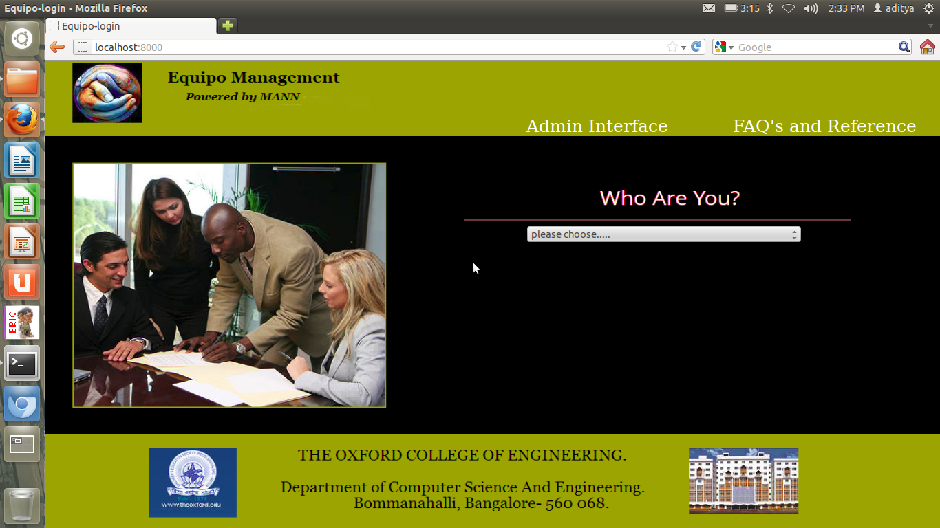

**Figure A.1 Snapshot of Equipo home page**

Figure A.1 represents the home page where all the three users can login to their respective dashboards. The admin can login to Equipo Administration from Home Page. Also the FAQ’s and reference page can be accessed where any user can view the references.

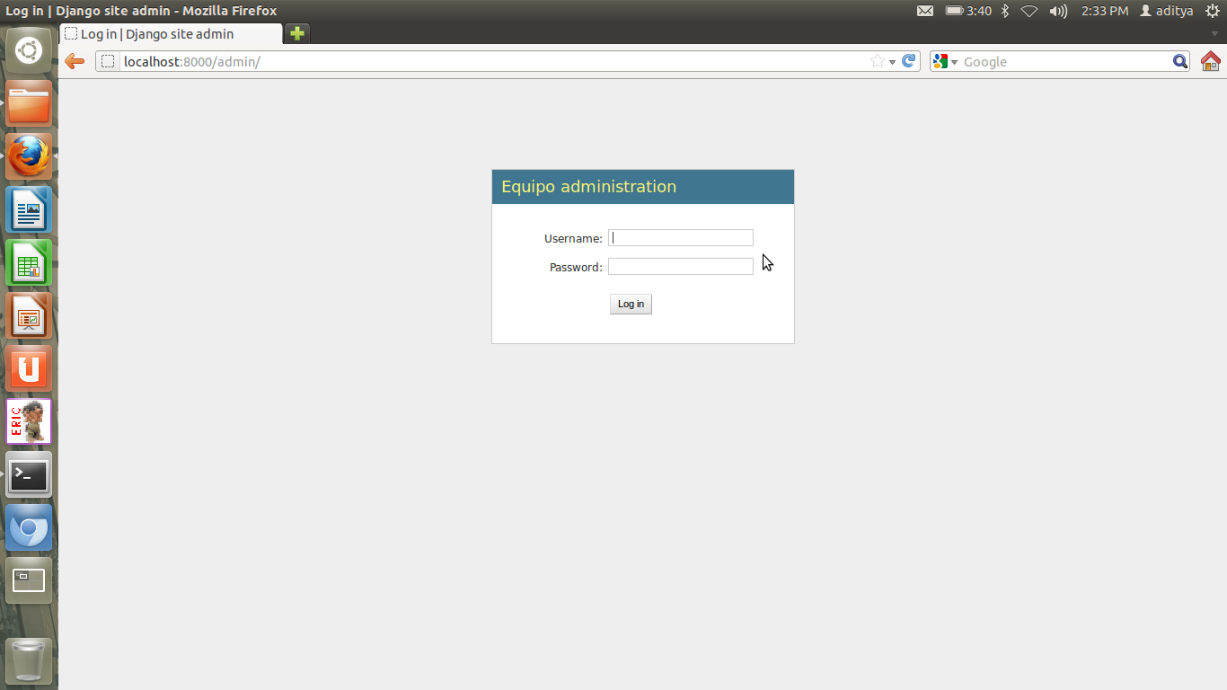

**Figure A.2 Snapshot of Admin Login page**

Figure A.2 is the login page for the for the Equipo Administrator. To login, the administrator uses the username and password. Once logged in the administrator can add users, open/close forums, make modifications to marks and change passwords.

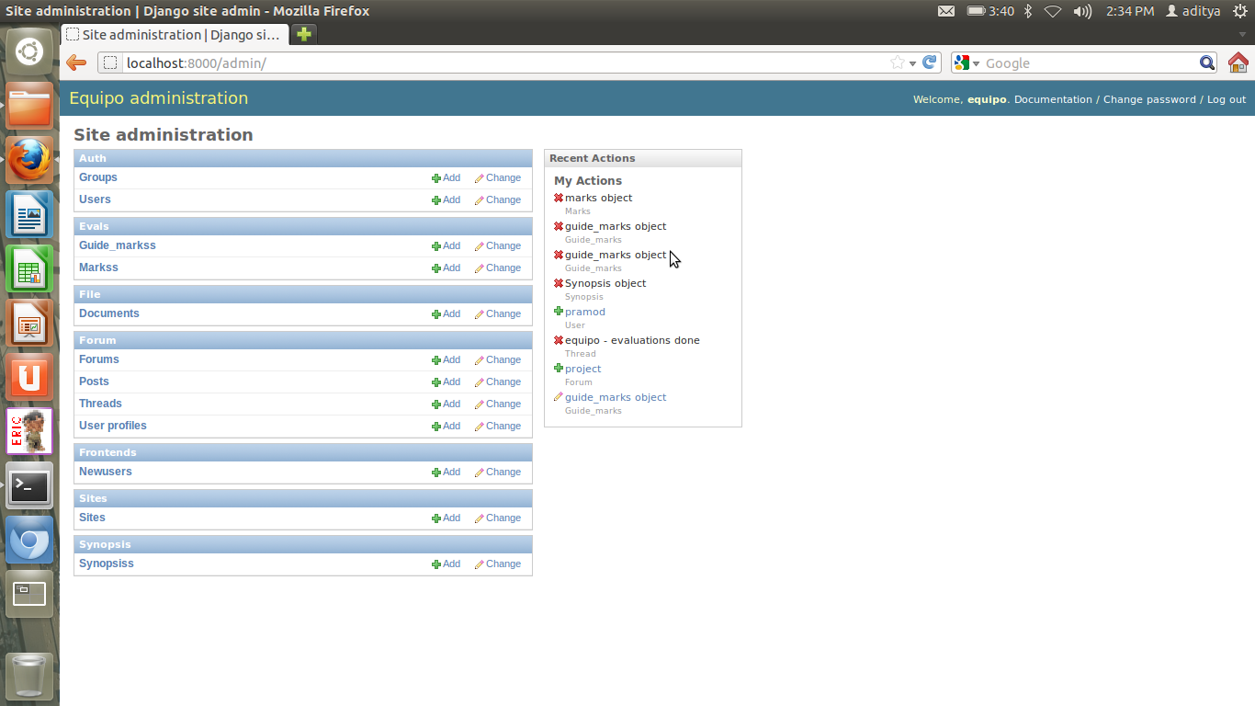

**Figure A.3 Snapshot of Admin Site**

Figure A.3 represents the admin site. Admin can add new users, wrongly evaluated marks (if any) can be corrected by the admin, forums can be open/closed, posts and threads can be deleted and also it is possible by the admin to back up documentations, files and synopsis uploaded by team member. Also to balance load on the server the admin can delete the uploaded files.

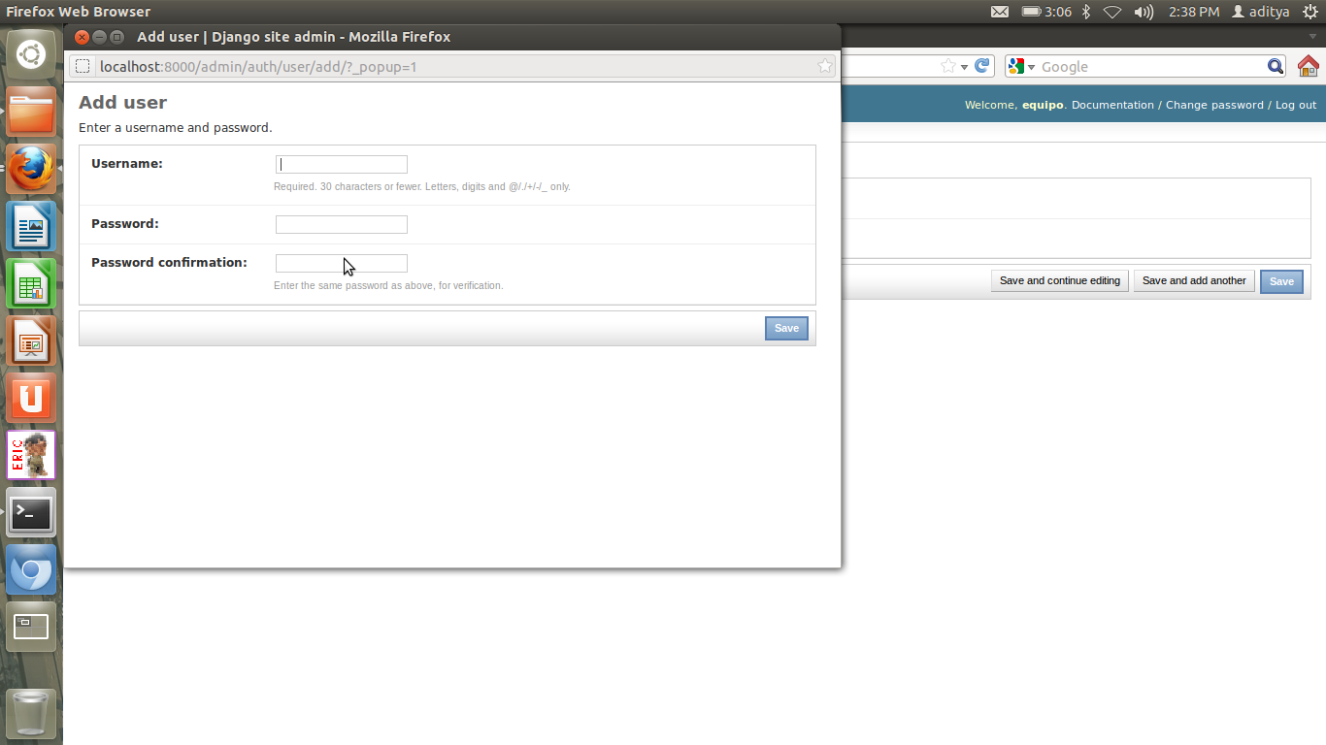**Figure A.4 Snapshot for adding new user**

Figure A.4 represents New User Registration Page. Here a new user can be added by the admin by giving him a new username and password.

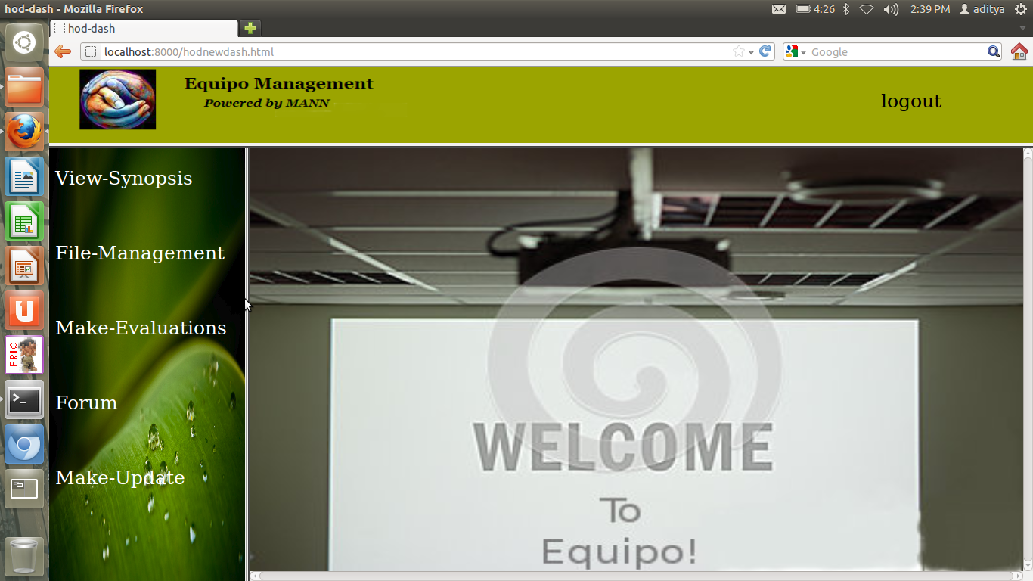

**Figure A.5 Snapshot of Head Of the Department-dashboard**

Figure A.5 represents Head Of the Department Dashboard. After a successful login the Head Of the Department is directed to the above page. The dashboard for Head Of the Department has features like view reports and synopsis, evaluate and give suggestions for improvement. From here it is also possible for the Head Of the Department to make updates regarding the project activities.

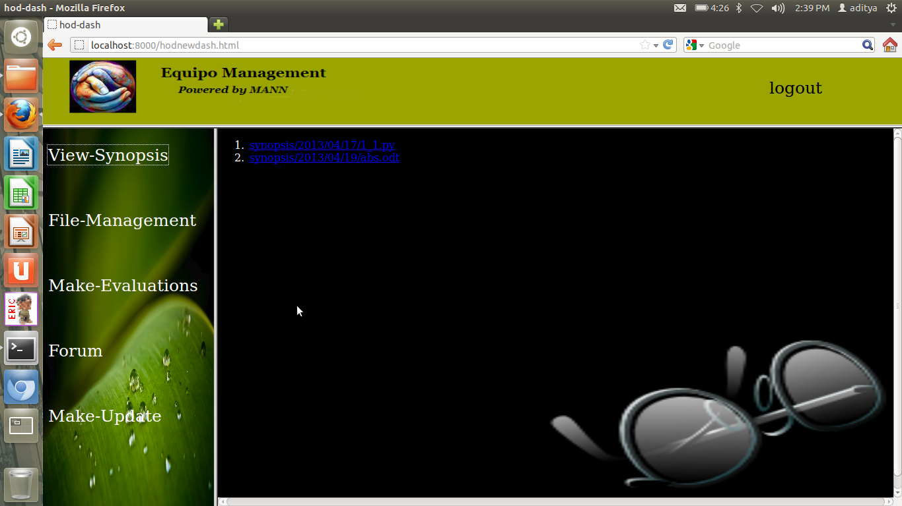

**Figure A.6 Snapshot for viewing uploaded synopsis**

Figure A.6 represents the view synopsis page where the Head Of the Department’s can view online or download the synopsis for offline reading, uploaded by the students.

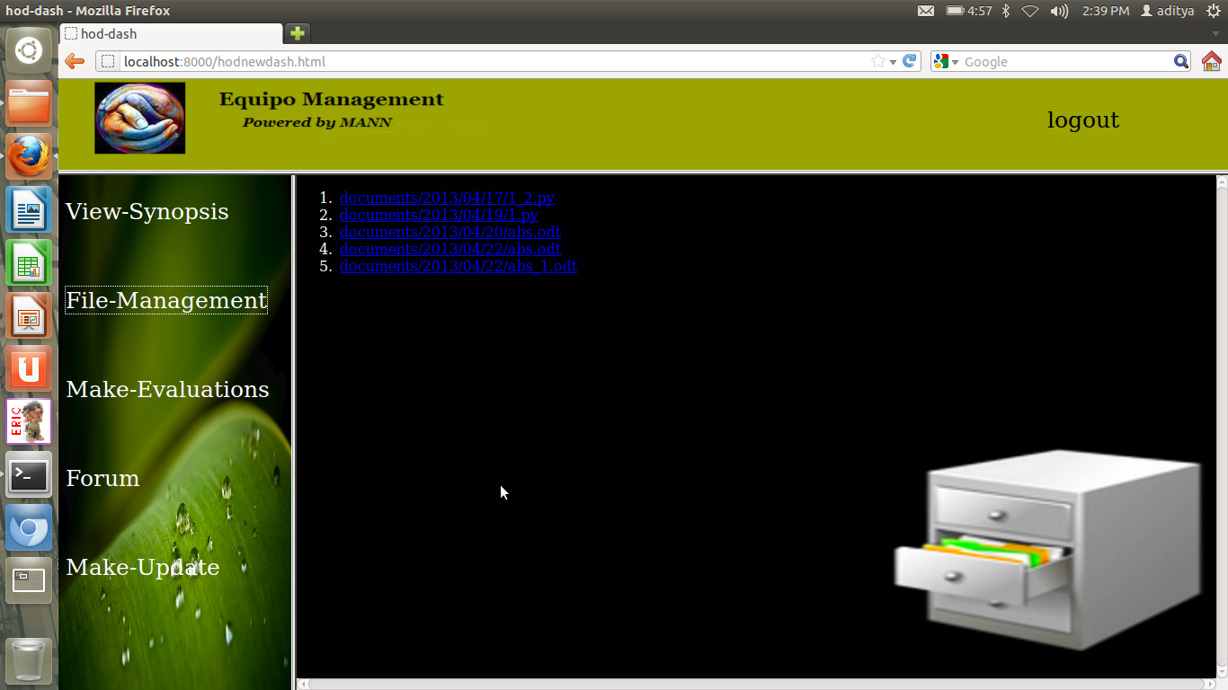

**Figure A.7 Snapshot of viewing uploaded documents**

Figure A.7 is the view documents page where the Head Of the Department’s can view online or download the documents for offline reading, uploaded by the students.

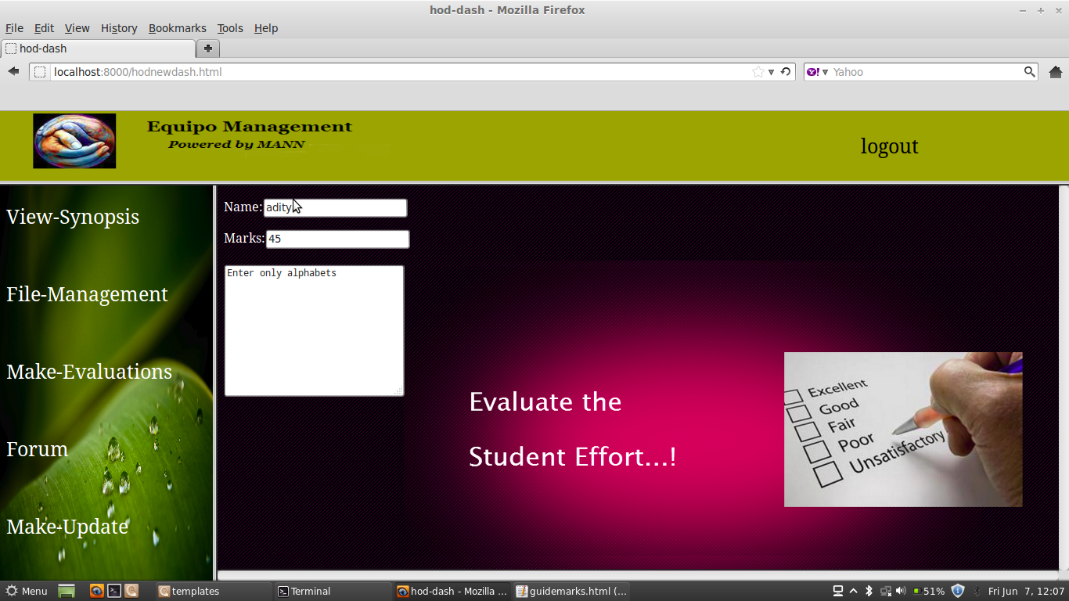

**Figure A.8 Snapshot of entering marks (Head Of the Department)**

Figure A.8 is the Make Evaluation option for the Head Of the Department where they can evaluate and assign marks to the students according to their progress. As shown in the snapshot the Head Of the Department have to enter the students name and respective marks in the given tab.

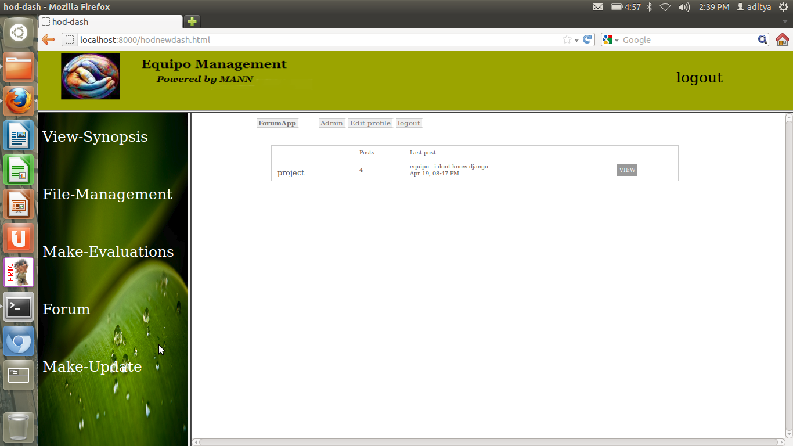

**Figure A.9 Snapshot of forum page**

Figure A.9 is the Forum page, once the forum is opened by the administrator it is possible for the Equipo users to post queries, view the posted queries and provide answers. The existing queries inside the forum can be viewed by clicking on the view button. Also the forum can be used as a means of communication between teams, guide’s and Head Of the Department.

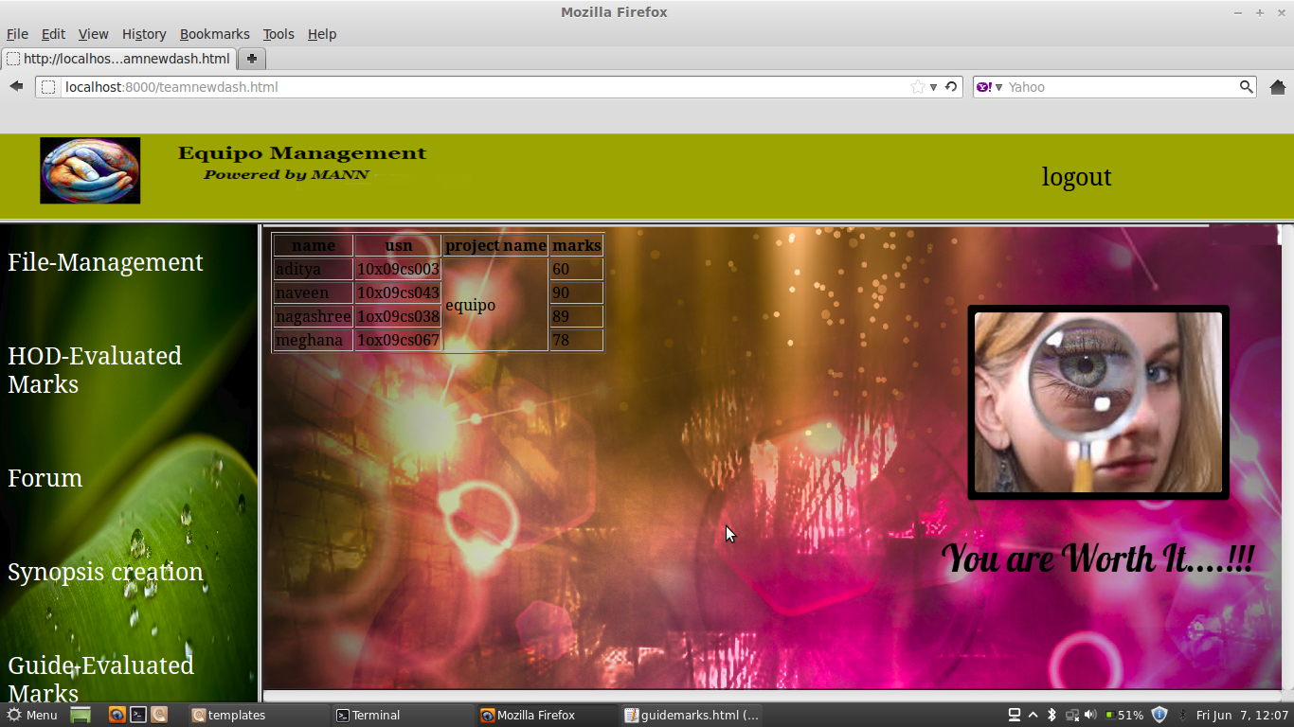

**Figure A.10 Snapshot of guide evaluation page**

Figure A.10 is the Make-Evaluation option for the guide’s and the respective guides of the students has to enter the names, USN and the marks of the students in the fields shown in the snapshot. If there are less than four members in the team then N/A is to be entered in the name and USN fields and zero is to be entered in the marks field.

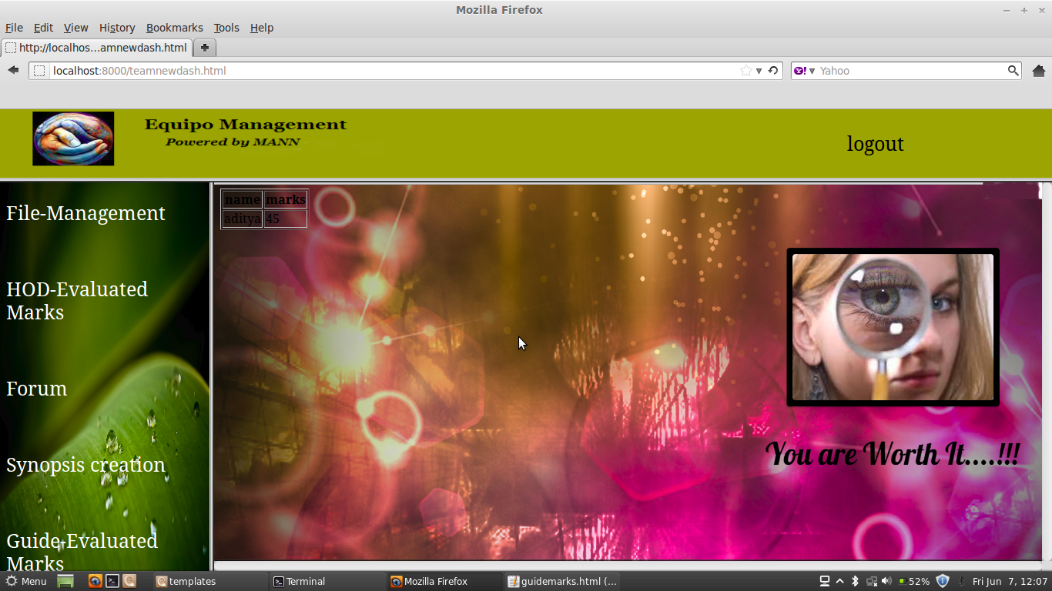

**Figure A.11 Snapshot of viewing Head Of the Department evaluated marks**

Figure A.11 shows the option for the Teams where the team members can view their respective marks evaluated by their Head Of the Department. As shown in the snapshot the student’s names along with their marks are displayed after clicking this option.

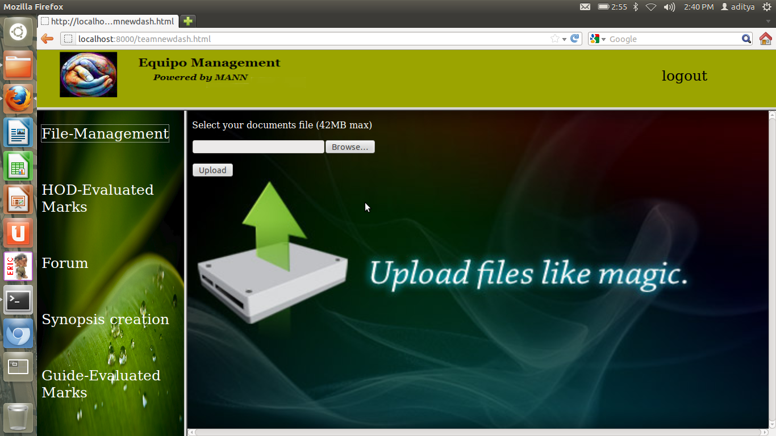

**Figure A.12 Snapshot of documents upload page**

Figure A.12 is the file management option in the Team dashboard where the team members can upload a specific file. The browse option allows the members to browse through their computer to upload the file which they have created. The upload file immediately uploads it into the Equipo system where it can be viewed or downloaded by the Head Of the Department or guides.

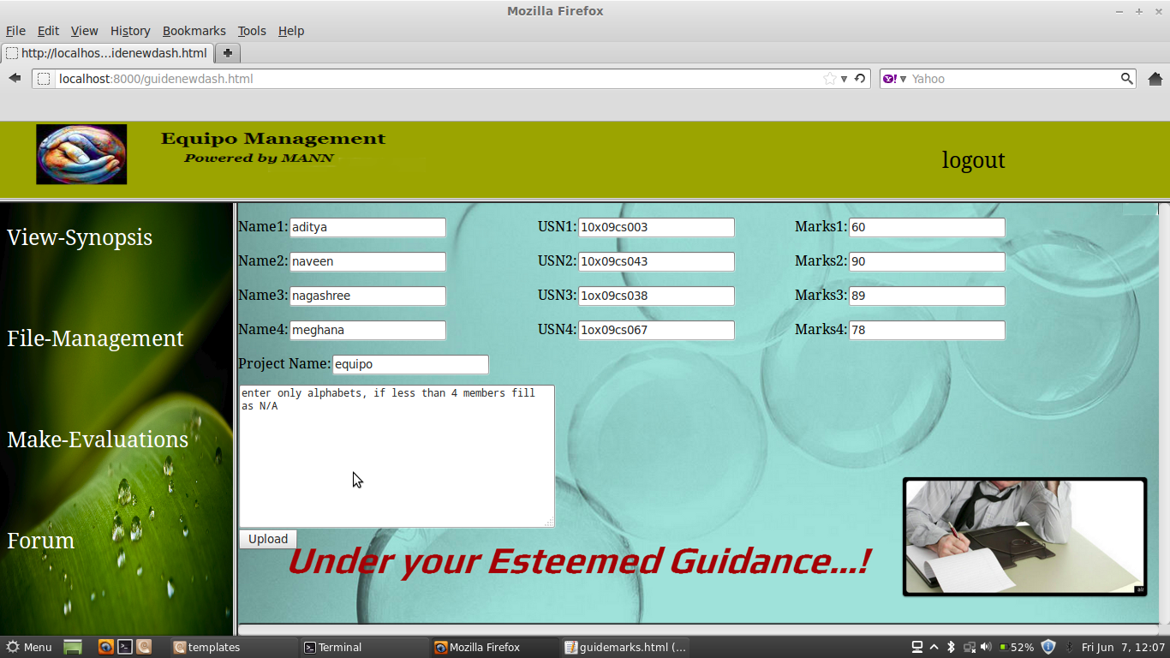

**Figure A.13 Snapshot of guide evaluated marks**

Figure A.13 is the option in the Team Dashboard where the team members can view their respective marks evaluated by their Guide’s. As shown in the snapshot the student’s names along with their USN, Project name and marks are displayed after clicking this option.

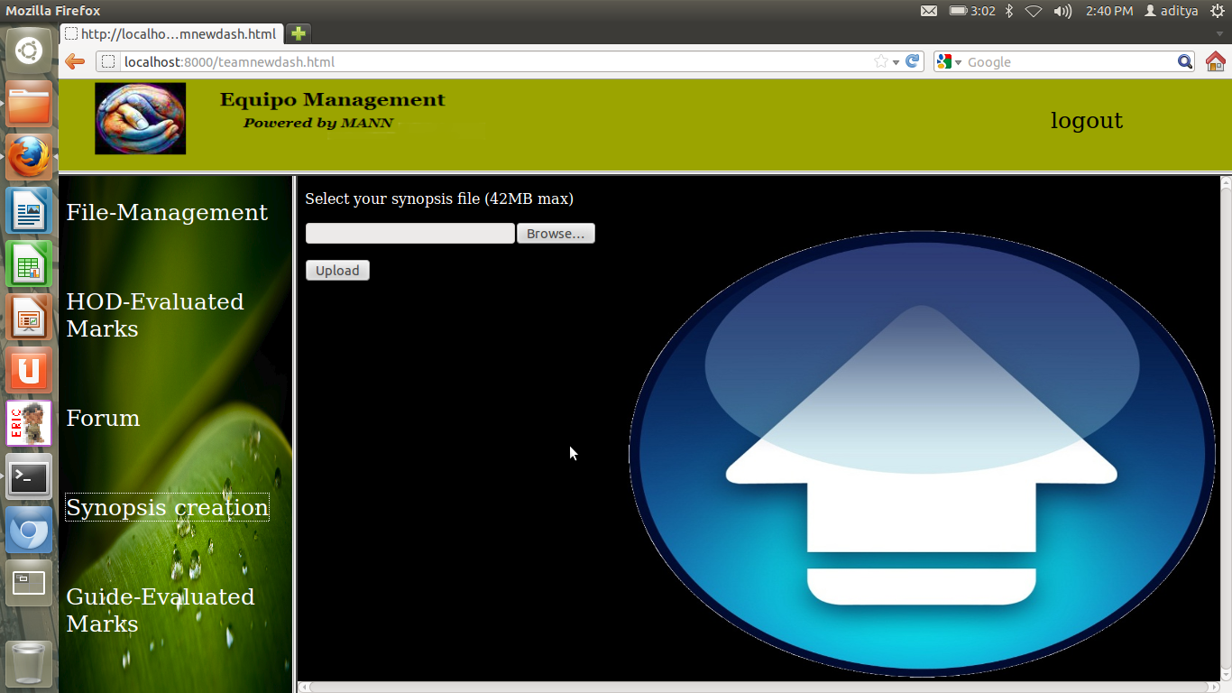

**Figure A.14 Snapshot of synopsis upload**

Figure A.14 is the Synopsis creation option in the Team dashboard where the team members can upload a specific synopsis. The browse option enables the members to browse through their computer to upload the synopsis which they have created. The upload file immediately uploads it into the Equipo system where it can be viewed or downloaded by the Head Of the Department and guides. Once the synopsis is uploaded a message will appear saying it’s uploaded as a confirmation.